CPE301 – SPRING 2019

Design Assignment 6

Student Name: Tian Chen

Student #: 2001086575

Student Email: chent5@unlv.nevada.edu

Primary Github address: <https://github.com/Chentian12138/AAAABBBBB>

Directory:DA6

Submit the following for all Labs:

1. In the document, for each task submit the modified or included code (only) with highlights and justifications of the modifications. Also, include the comments.
2. Use the previously create a Github repository with a random name (no CPE/301, Lastname, Firstname). Place all labs under the root folder ESD301/DA, sub-folder named LABXX, with one document and one video link file for each lab, place modified asm/c files named as LabXX-TYY.asm/c.
3. If multiple asm/c files or other libraries are used, create a folder LabXX-TYY and place these files inside the folder.
4. The folder should have a) Word document (see template), b) source code file(s) and other include files, c) text file with youtube video links (see template).

1. **COMPONENTS LIST AND CONNECTION BLOCK DIAGRAM w/ PINS**

Atmega 328p and mpu 6050

1. **INITIAL/MODIFIED/DEVELOPED CODE OF TASK 1/A**

/*

* DA 6.c

*

* Created: 5/5/2019 11:46:25 PM

* Author : chent

*/

#define *F_CPU* 16000000UL // Board running at 16MHz

#include <avr/io.h>

#include <util/delay.h>

#include <inttypes.h>

#include <stdlib.h>

#include <stdio.h>

#include "MPU6050_res_define.h" //

#include "I2C_Master_H_file.h" // Include necessary libraries

#include "USART_RS232_H_file.h" //

double acc_X; //

double acc_Y; //

double acc_Z; // Declare all variables for Accelerometer and Gyroscope

double gyro_X; //

double gyro_Y; //

double gyro_Z; //

void MPU6050_Init() // Gyro initialization function

{

*_delay_ms*(150); // power up time

I2C_Start_Wait(0xD0); // start with device write address

I2C_Write(SMPLRT_DIV); // write to sample rate register

I2C_Write(0x07); // 1KHz sample rate

I2C_Stop();

I2C_Start_Wait(0xD0); // start with device write address

I2C_Write(PWR_MGMT_1); // write to power management register

I2C_Write(0x01); // Reference frequency of X axis gyroscope

I2C_Stop();

I2C_Start_Wait(0xD0); // start with device write address

I2C_Write(CONFIG); // write to configuration register

I2C_Write(0x00); // Fs = 8KHz

I2C_Stop();

I2C_Start_Wait(0xD0); // start with device write address

I2C_Write(GYRO_CONFIG); // write to Gyro configuration register

I2C_Write(0x18); // Celsius +/- 2000 degrees

I2C_Stop();

I2C_Start_Wait(0xD0); // start with device write address

I2C_Write(INT_ENABLE); // rite to interrupt enable register

I2C_Write(0x01);

I2C_Stop();

}

void MPU_Start_Loc()

{

I2C_Start_Wait(0xD0); // I2C start with device write address

I2C_Write(ACCEL_XOUT_H); // Write start location address from where to read

I2C_Repeated_Start(0xD1); // I2C start with device read address

}

void Read_RawValue()

{

MPU_Start_Loc(); //

accelerometer_X = (((int)I2C_Read_Ack()<<8) | (int)I2C_Read_Ack()); //

accelerometer_Y = (((int)I2C_Read_Ack()<<8) | (int)I2C_Read_Ack()); //

accelerometer_Z = (((int)I2C_Read_Ack()<<8) | (int)I2C_Read_Ack()); // read value of Gyroscope

gyroscope_X = (((int)I2C_Read_Ack()<<8) | (int)I2C_Read_Ack()); //

gyroscope_Y = (((int)I2C_Read_Ack()<<8) | (int)I2C_Read_Ack()); //

gyroscope_Z = (((int)I2C_Read_Ack()<<8) | (int)I2C_Read_Nack()); //

I2C_Stop();

}

int main()

{

char buffer[20], float_[10];

float Xa,Ya,Za;

float Xg=0,Yg=0,Zg=0;

I2C_Init(); // initialize I2C

MPU6050_Init(); // initialize MPU6050

USART_Init(9600); // initialize USART with 9600 baud rate

while(1)

{

Read_RawValue();

Xa = acc_X/16384.0; // To obtain real values, divide raw value by scale factor

Ya = acc_Y/16384.0;

Za = acc_Z/16384.0;

Xg = gyro_X/16.4;

Yg = gyro_Y/16.4;

Zg = gyro_Z/16.4;

*dtostrf*( Xa, 3, 2, float_ );

*sprintf*(buffer," Ax = %s g\t",float_);

USART_SendString(buffer);

*dtostrf*( Ya, 3, 2, float_ );

*sprintf*(buffer," Ay = %s g\t",float_);

USART_SendString(buffer);

*dtostrf*( Za, 3, 2, float_ );

*sprintf*(buffer," Az = %s g\t",float_);

USART_SendString(buffer);

*dtostrf*( Xg, 3, 2, float_ );

*sprintf*(buffer," Gx = %s%c/s\t",float_,0xF8);

USART_SendString(buffer);

*dtostrf*( Yg, 3, 2, float_ );

*sprintf*(buffer," Gy = %s%c/s\t",float_,0xF8);

USART_SendString(buffer);

*dtostrf*( Zg, 3, 2, float_ );

*sprintf*(buffer," Gz = %s%c/s\r\n",float_,0xF8);

USART_SendString(buffer);

*_delay_ms*(1000);

}

}

1. **SCHEMATICS**

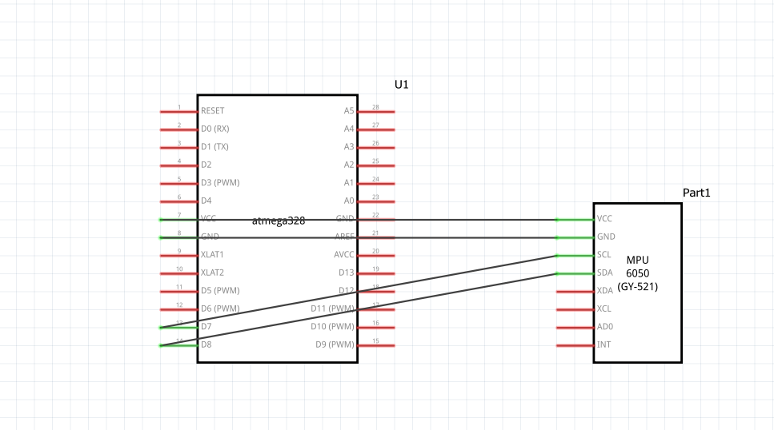

1. **SCREENSHOTS OF EACH TASK OUTPUT (ATMEL STUDIO OUTPUT)**

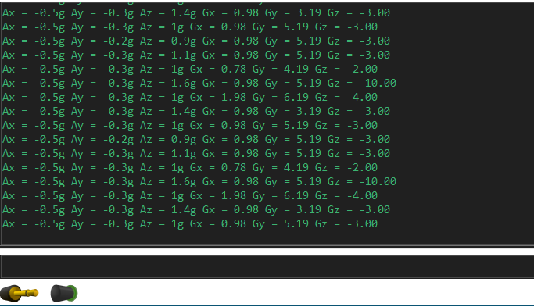

1. **SCREENSHOT OF EACH DEMO (BOARD SETUP)**

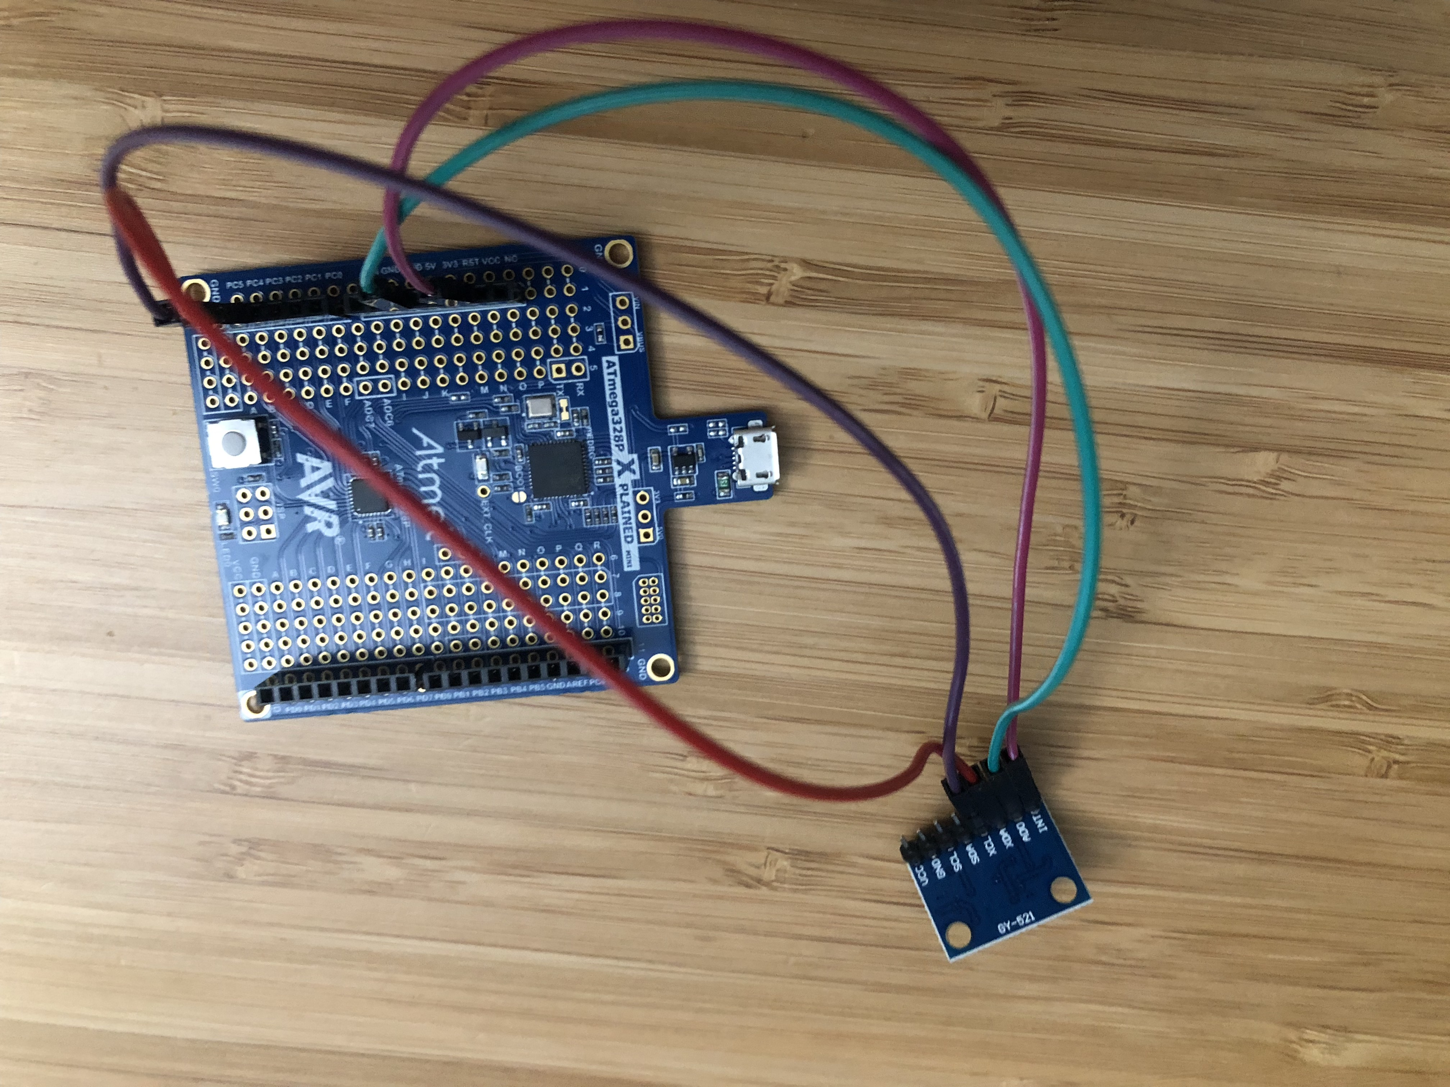

1. **GITHUB LINK OF THIS DA**

<https://github.com/Chentian12138/AAAABBBBB>

**Student Academic Misconduct Policy**

<http://studentconduct.unlv.edu/misconduct/policy.html>

“This assignment submission is my own, original work”.

NAME OF THE STUDENT